In the begening of Java (1.0v to 1.2v) Java I.O was very important for java developer as in the early stage file was the only storage where data can be stored in the file form, as that time database concept was not popular. Form 1.2V database concept become popular and so File I.O concept become less popular.

But again from Java 1.5 V file I.O concept become popular once again as for storing large amount of data, database concept is suitable option but for storing small amount of data DB concept is not siltable as for small amount of data also we need to buy licence etc. So for small amount of data storage file concept become more popular.

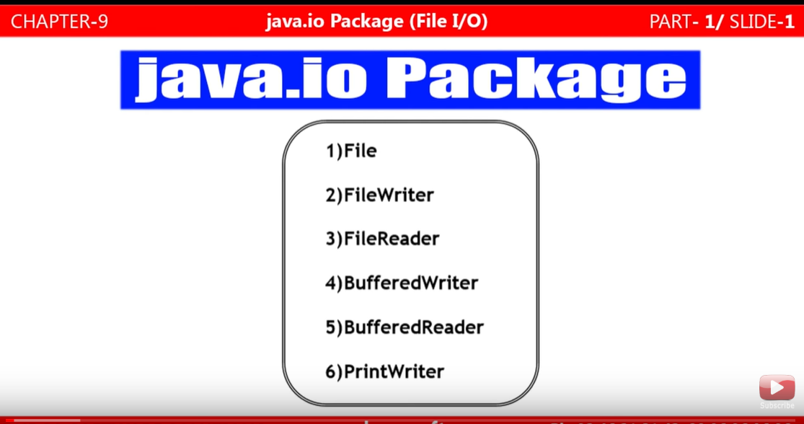

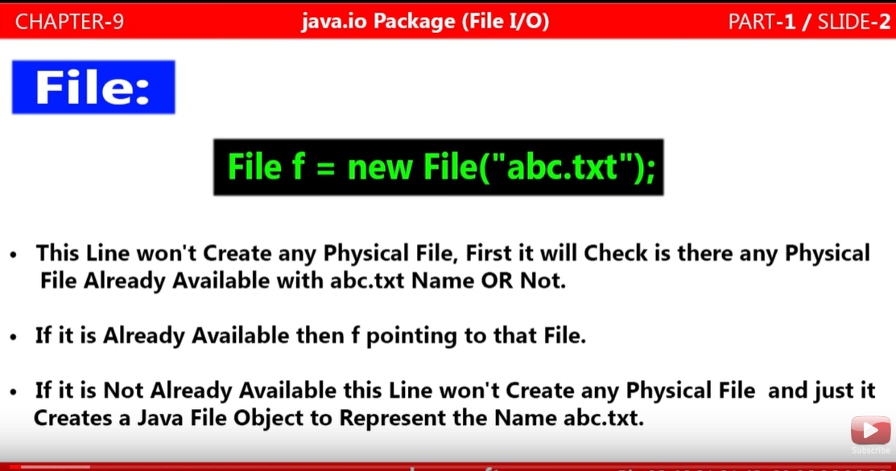

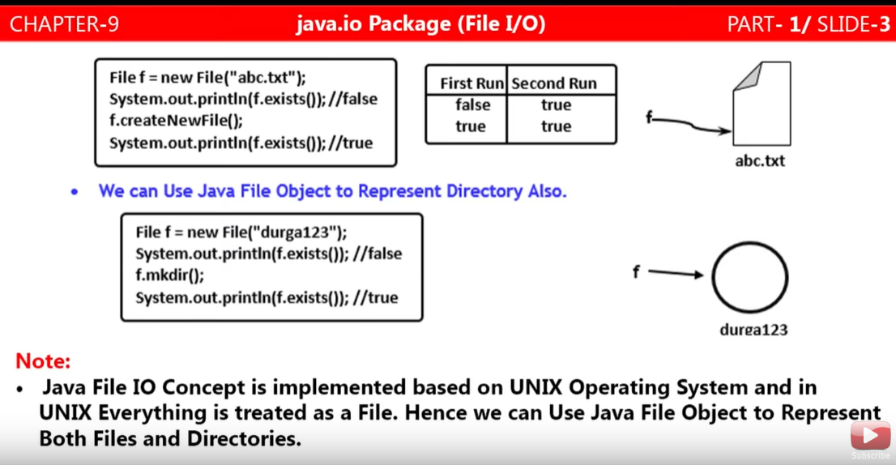

**Creating File using File I/O**

|  |
| --- |
| **package**com.file.handling;  **import**java.io.File;  **import**java.io.IOException;  **publicclass**FileHandling {  **publicstaticvoid**main(String[] args) **throws** IOException {    // Creating an object of a file class  File file = **new** File("abc.txt");  System.***out***.println(file.exists());  file.createNewFile();  System.***out***.println(file.exists());  }  } |
| File file = **new** File("abc.txt");  **This line won’t create any physical file, first it will check that whether file is already existing or not in the workspace directory** |
| file. createNewFile ();  **This line will create a new file if file is already not existingin the current workspace directory** |
| file.exists()  **This line return Boolean and it just check that whetherfile is existing or not in the workspace directory** |

**Note**: When we run the above program then in the first run the output will be (false and true) as in the first run file is not available physically in the directory so the first file.exists() will return false and second file.exists() will return true as the above code [file.createNewFile();] has created the file in the current working directory.

**Note**: In the second run, the output will (true and true) as the file would have been created in the first run by [file.createNewFile();]so first and last file.exists() will return true & true.

**Creating Directory / Folder using File I/O**

|  |
| --- |
| **package**com.file.handling;  **import**java.io.File;  **import**java.io.IOException;  **publicclass**FileHandling {  **publicstaticvoid**main(String[] args) **throws** IOException {    // Creating an object of a file class  File dir = **new** File("NewFolder");  System.***out***.println(dir.exists());  dir.mkdir();  System.***out***.println(dir.exists());  }  } |
| dir.mkdir();  **Creates a directory with name** NewFolder. |

**UNIX Concept for Java file concept: Example given above**

**Various Constructor present in File class:**

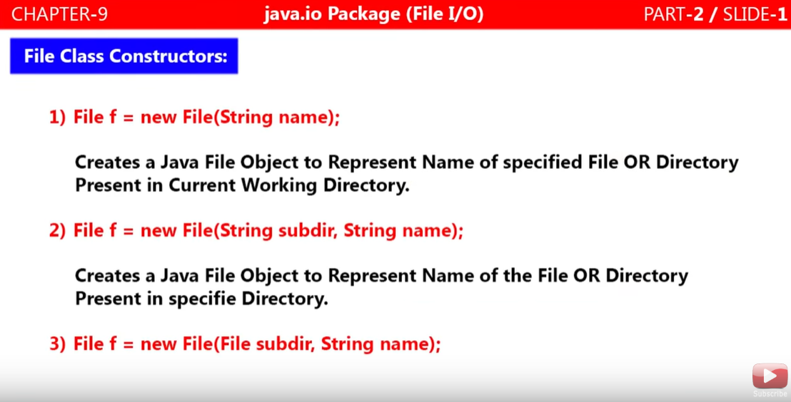

**Code for creating directory and file in the created directory**

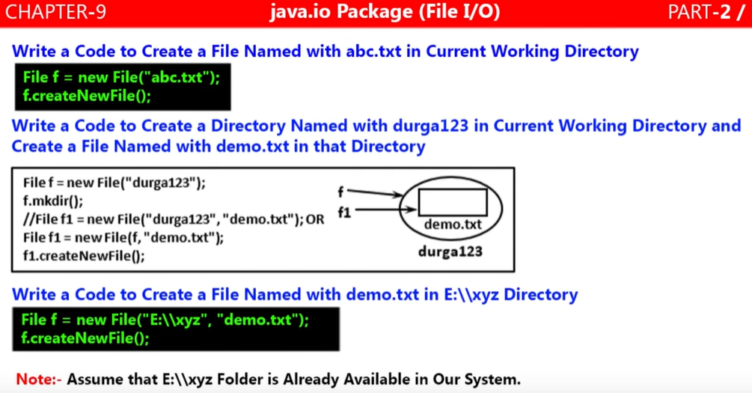

|  |
| --- |
| **package** com.file.handling;  **import**java.io.File;  **import**java.io.IOException;  **public class** FileInsideFolder {  **public static void** main(String[] args){    File folder= **new** File("FileFolder");  folder.mkdir();  File file = **new** File(folder, "extract.csv");  **try** {  file.createNewFile();  } **catch** (IOException e) {  e.printStackTrace();  }  }   1. First created FileFolder directory using mkdir 2. Then creating file extract.csv by passing created directory reference and createNewFile () method.   } |
| **package**com.file.handling;  **import**java.io.File;  **import**java.io.IOException;  **publicclass**FileInsideFolder {  **publicstaticvoid**main(String[] args){    File dir= **new** File("FileFolder1");  // Creating file refer dir for creating FileFolder1 dir or folder  dir.mkdir();  // creating dir using mkdir ()  File file1 = **new** File("FileFolder1","Filetxt32.txt"); OR  // creating file reference file1 to create file inside dir or folder  File file = **new** File(dir,"Filetxt32.txt");  **try** {  file. createNewFile ();  // code to create Filetxt32.txt file inside dir or FileFolder1  System.***out***.println("File Created Successfully");  } **catch** (IOException e) {  e. printStackTrace ();  }  }  } |

**Important methods present in File Class:**

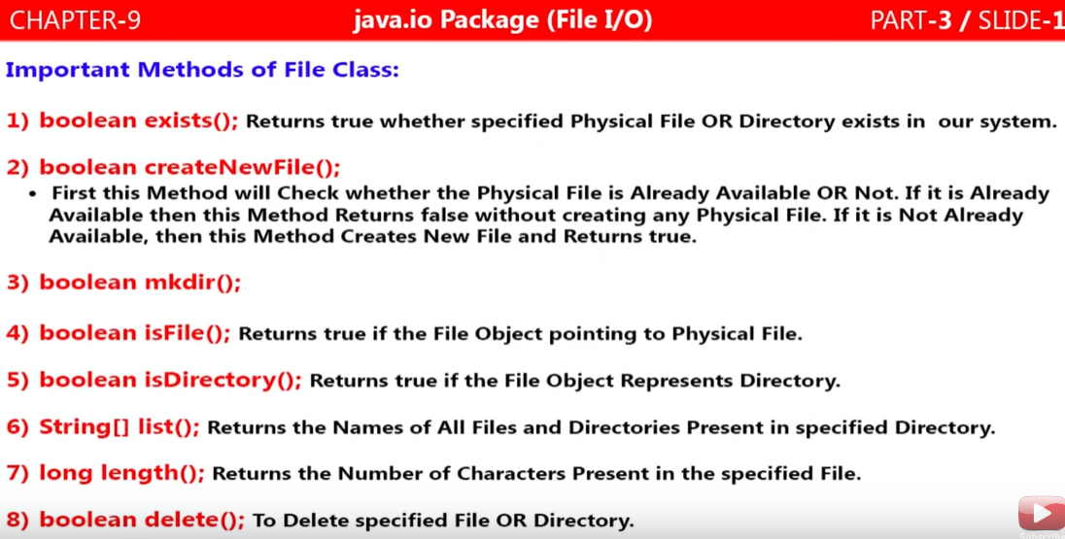

|  |  |
| --- | --- |
| 1. **booleanexists()** | **Returns true if specified physical file or directory is available in system else return false** |
| 1. **Boolean createNewFile()** | **Returns false if specified physical file is already available and does not create file. If file is not available then it returns true and creates a specified physical file.** |
| 1. **Boolean mkdir()** | **Returns false if specified physical directory or folder is already available and does not create file. If directory or folder is not available then it returns true and creates a specified physical directory or folder.** |
| 1. **Boolean isFile()** |  |
| 1. **Boolean isDirectory()** |  |
| 1. **String[] list()** |  |
| 1. **Long length()** |  |
| 1. **Boolean delete()** |  |

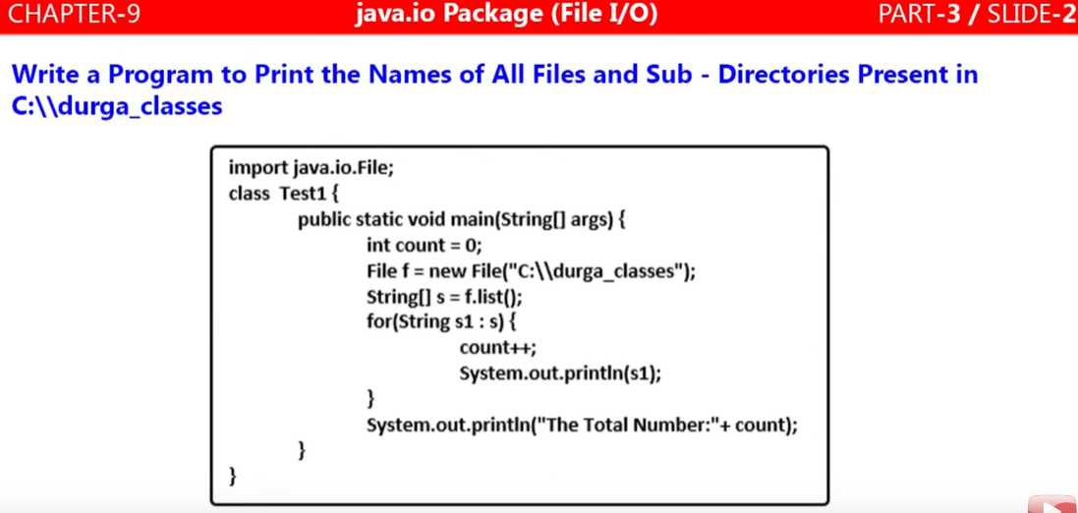

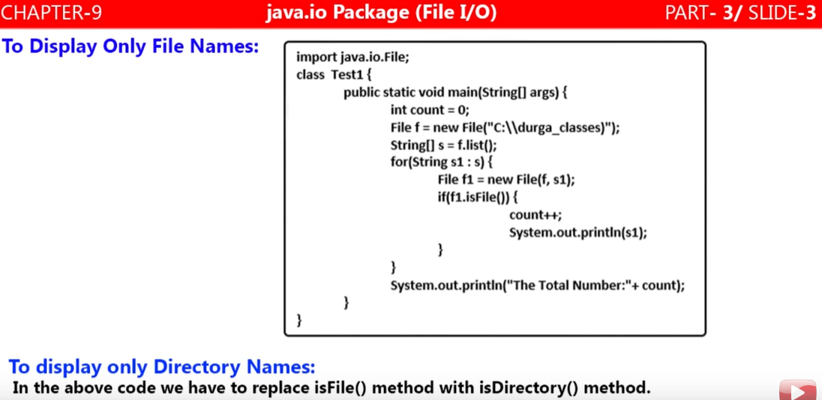

**Program to display and count total number of folder and file inside directory of folder:**

|  |  |
| --- | --- |
| **package**com.file.handling;  **import**java.io.File;  **publicclass** ListingAllFileAndDirectory {  **publicstaticvoid**main(String[] args) {  **int**count=0;  File f = **new** File("D:\\");  String[] s = f.list();  **for**(String s1 : s) {  count++;  System.***out***.println(s1);  }  System.***out***.println("Total number is"+count);  }  } | **Output**:  $RECYCLE.BIN  Employee Salary Query.sql  FileFolder  FileHandlingNewFilef2.csv  Spring Boot  Spring boot 28 min  System Volume Information  Total number is7 |

|  |  |
| --- | --- |
| **package**com.file.handling;  **import**java.io.File;  **publicclass** ListingAllFileAndDirectory {  **publicstaticvoid**main(String[] args) {  **int**count=0;  File f = **new** File("D:\\");  String[] s = f.list();  **for**(**int**i=0;i<=s.length; i++) {  //for(String s1 : s) {  count++;  System.***out***.println(s[i]);  }  System.***out***.println("Total number is"+count);  }  } | **Ouput:**  Employee Salary Query.sql  FileFolder  FileHandlingNewFilef2.csv  Spring Boot  Spring boot 28 min  System Volume Information  Exception in thread "main" java.lang.ArrayIndexOutOfBoundsException: 7at com.file.handling.ListingAllFileAndDirectory.main(ListingAllFileAndDirectory.java:12)  We are getting exception for  System.***out***.println(s[i]); |
| **So correct code:**  **package**com.file.handling;  **import**java.io.File;  **publicclass** ListingAllFileAndDirectory {  **publicstaticvoid**main(String[] args) {  **int**count=0;  File f = **new** File("D:\\");  String[] s = f.list();  **for**(**int**i=0;i<s.length; i++) {  //for(String s1 : s) {  count++;  System.***out***.println(s[i]);  }  System.***out***.println("Total number is"+count);  }  } | **Ouput:**  **In the above example the problem was in for loop**  **for**(**int**i=0;**i<=s.length**; i++)  that is why we got above exception.  $RECYCLE.BIN  Employee Salary Query.sql  FileFolder  FileHandlingNewFilef2.csv  Spring Boot  Spring boot 28 min  System Volume Information  Total number is7 |

**Difference between For and for each loop**

**So, to retrieve arrays or collection element we should use for each loop above example.**

1. **For each loop is an enhanced form of for loop, introduced in java 1.5 V**
2. **For each loop is specially designed to retrieve elements of arrays and collection**

**To print element of one-dimensional array using normal for loop and for each loop:**

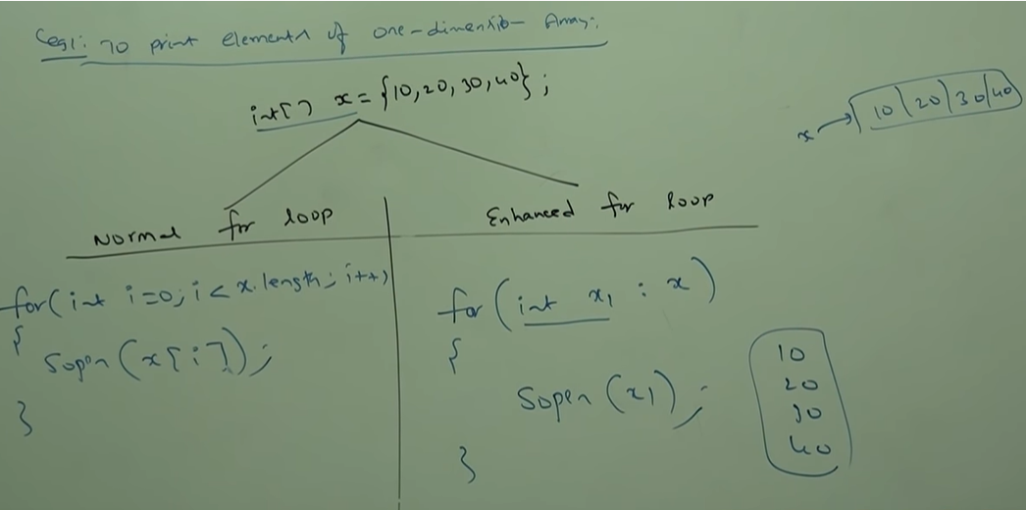

**To print element of two-dimensional array using normal for loop and for each loop:**

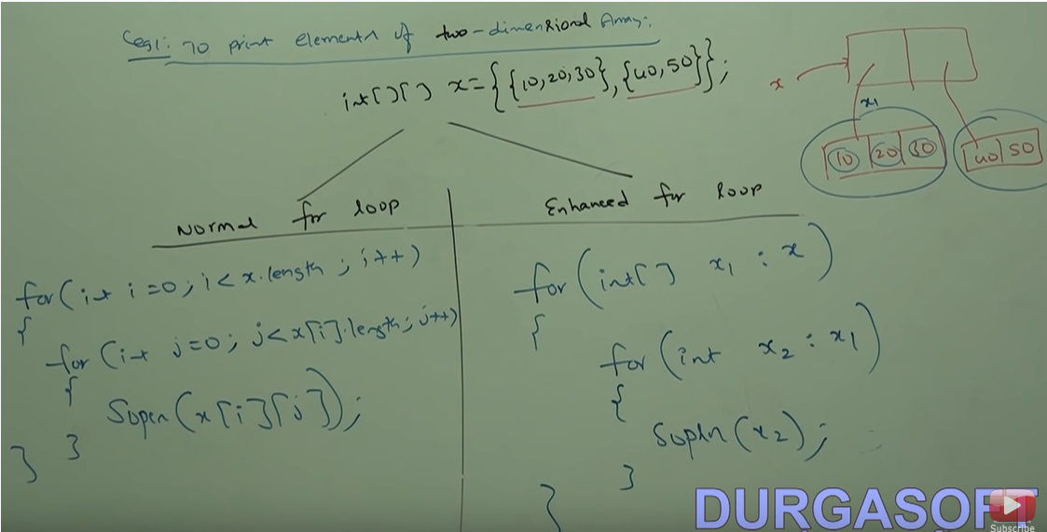

**To print three-dimensional loop using for each loop:**

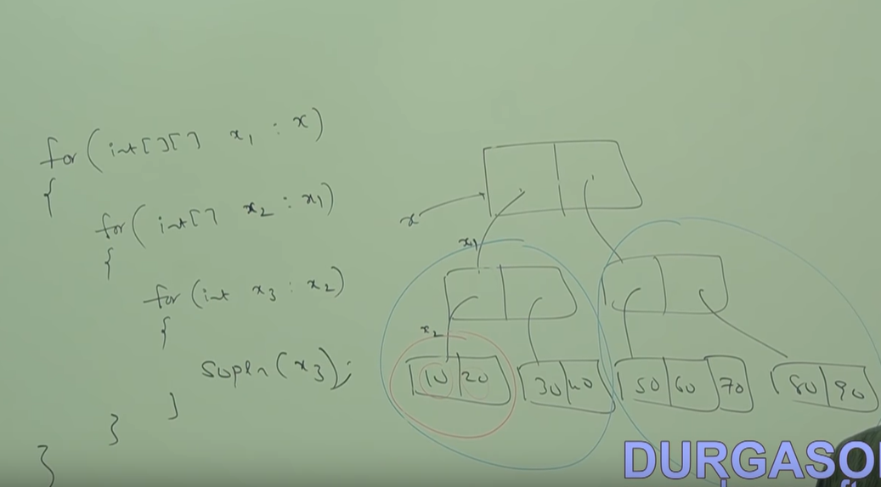**Hence for each loop make our life easy in case of multi-dimensional.**

**Limitation of for each loop:**

1. **For each loop is specially designed to retrieve arrays values and collections element, so for each loop cannot use as general for loop.**

**Hence for each loop is best choice to retrieve element of arrays and collections but its limitation is it is applicable only for arrays and collections and it is not a general purpose loop.**

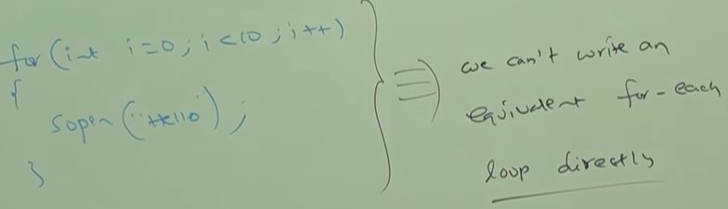

1. **By using normal for loop we can print array element either In original order or in reverse order. But by using for each loop we can print array element only in original order but not in reverse order.**

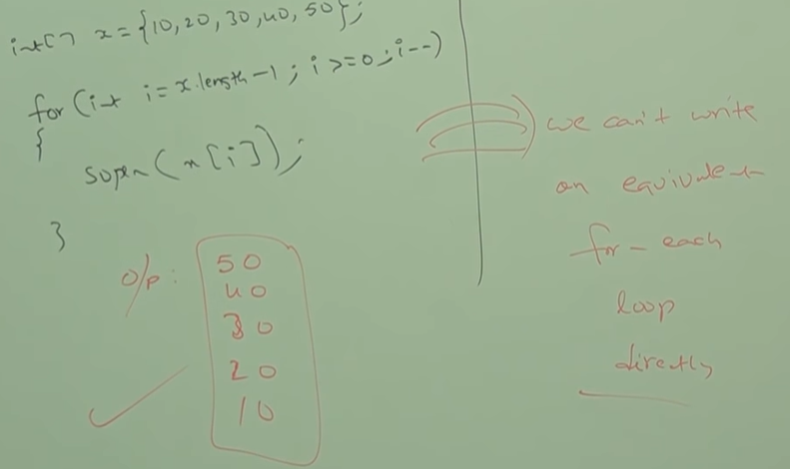

1. **The target element in for each loop should be iterable object. An element is called iterable iff it implements iterable (I)java.lang.interface. All arrays and collections classes already implemented Iterable interface. Being a programmer, we should aware with this concept.**

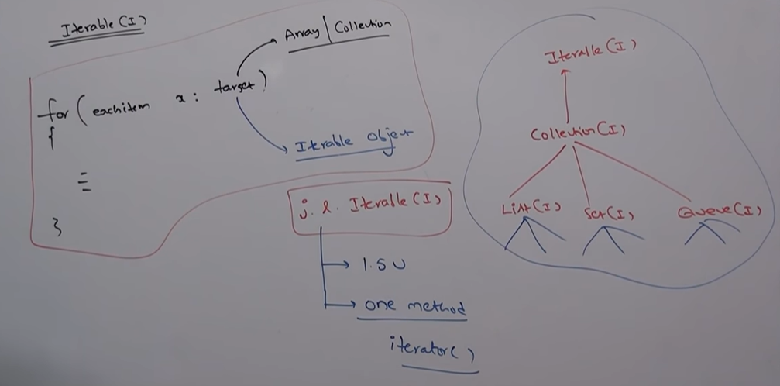

**Iterable(I) introduce in java 1.5 V and it contains only one method [public Iterator iterator ()].**

**Difference between Iterator(I) and Iterable(I)**

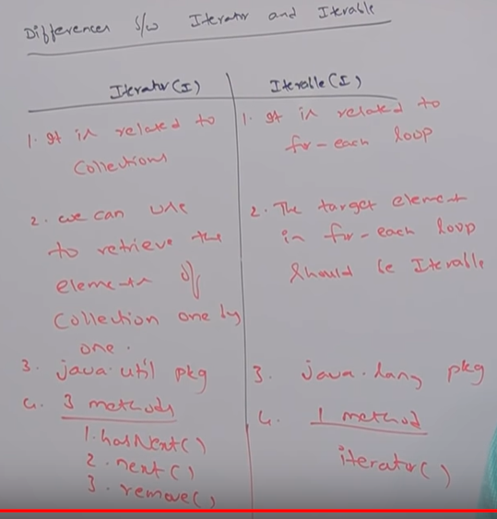

**Program to count and display only file from the directory or folder:**

|  |  |
| --- | --- |
| **package**com.file.handling;  **import**java.io.File;  **publicclass**ListingFileOnly {  **publicstaticvoid**main(String[] args) {  **int**count =0;  File file = **new** File("D:\\");  String[] s= file.list();  **for**(Strings1 : s) {  File f = **new**File(file, s1);  **if**(***f.isFile()***) {  count++;  System.***out***.println(s1);  }  }  **System.*out*.println("Total files are: "+count);**  }  } | **Output:**  Employee Salary Query.sql  FileHandlingNewFilef2.csv  New Microsoft Word Document.docx  Total files are: 3 |

**Program to count and display only folder from the directory or folder:**

|  |  |
| --- | --- |
| **package**com.file.handling;  **import**java.io.File;  **publicclass**ListingFileOnly {  **publicstaticvoid**main(String[] args) {  **int**count =0;  File file = **new** File("D:\\");  String[] s= file.list();  **for**(String s1 : s) {  File f = **new**File(file, s1);  **if**(***f.isDirectory()***) {  count++;  System.***out***.println(s1);  }  }  System.***out***.println("Total files are: "+count);  }  } | **Output:**  $RECYCLE.BIN  FileFolder  Spring Boot  Spring boot 28 min  System Volume Information  Total files are: 5 |

**Note:** isFile () and isDirectory () method should be call on file object not on string object that is why, created a new file object inside for each loop and passing main root file object and for each string object. [**File f = new File (file, s1);]**

**Up to this we have learnt to create file, directory and listing of file/directory. Now we will learn how to write data in the file and how to read data from the file**

**FileWriter:** To write character data or text data to the file

**FileReader:** To read character data or text data from the file

**FileWriter class**

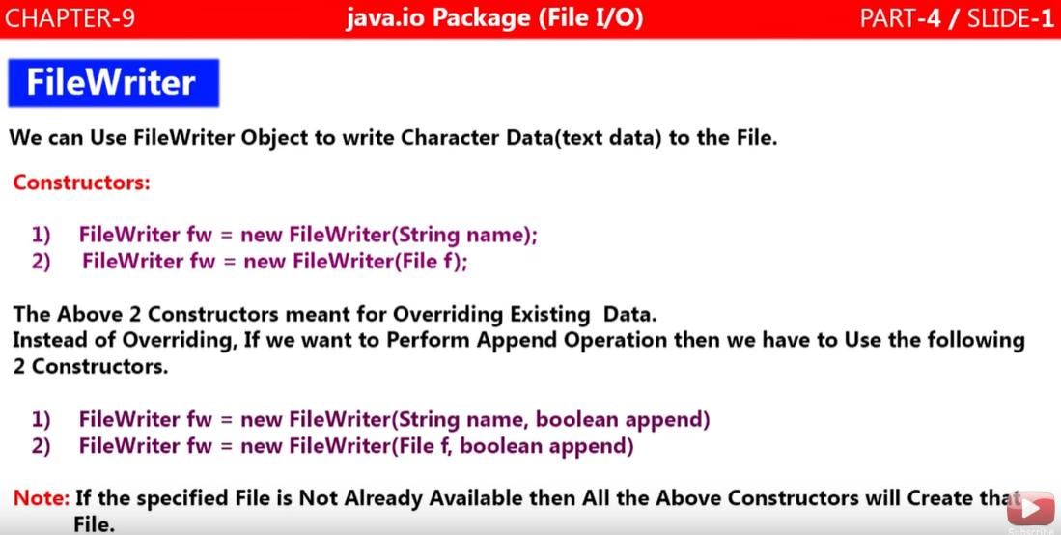

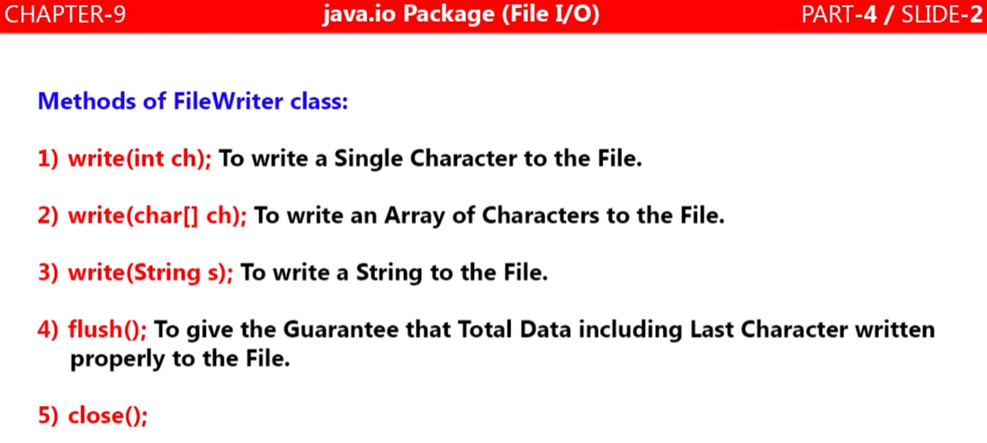

|  |  |
| --- | --- |
| **package**com.file.handling;  **import**java.io.FileWriter;  **import**java.io.IOException;  **publicclass**FileWriterExample {  **publicstaticvoid**main(String[] args) **throws** IOException {    FileWriter fw = **new** FileWriter("abc.txt");  fw.write(100);  fw.write("Hi Welcome to java fw");  fw.write("\n");  **char** [] ch1= {'a','b','c'};  fw.write(ch1);  fw.write("\n");  fw.flush();  fw.close();  }  } | Output :  dHi Welcome to java fw  abc |

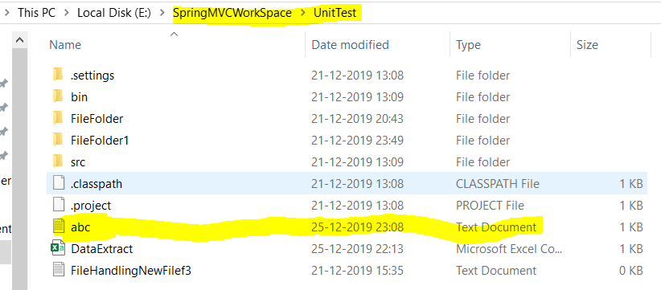

FileReader Class

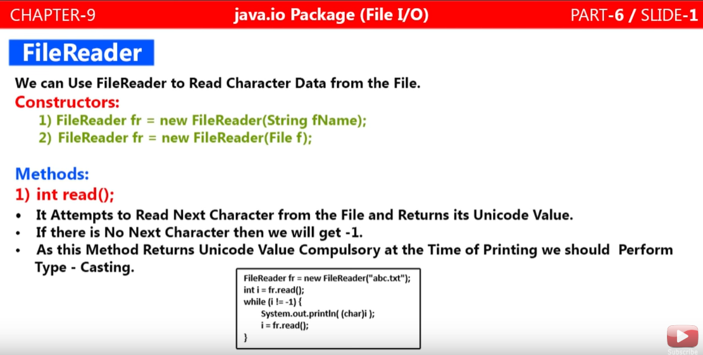

|  |  |
| --- | --- |
| **package**com.file.handling;  **import**java.io.FileReader;  **import**java.io.IOException;  **publicclass**FileReaderDemo {  **publicstaticvoid**main(String[] args) **throws** IOException {  FileReader fr = **new** FileReader("abc.txt");  **int**i = fr.read();  **while**(i!=-1) { // unti I is not equal to -1 blank letter  System.***out***.print((**char**)i);  i=fr.read();  }  fr.close();  }  } | Output:  dHi Welcome to java fwabc |

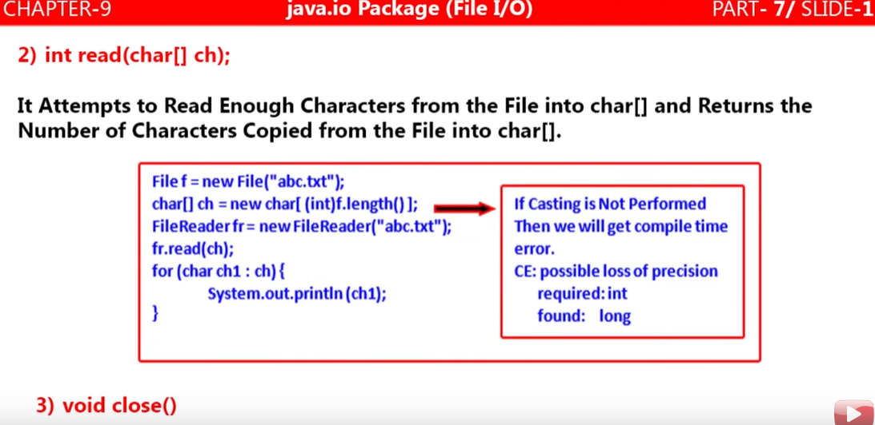

**Note: Go through videos and exercise example in eclipse**

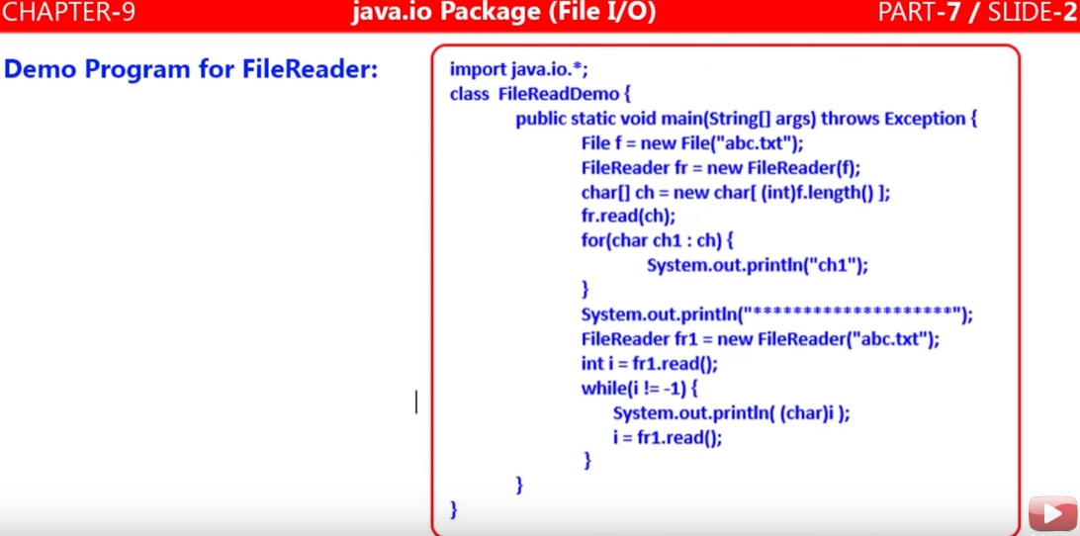

**Note: By using FileReader we can read data character by character which is not convenient. So the second method introduced which is capable to read file line by line which is more faster and convenient in case of big file .**

**FileWriter and FileReader is not recommended to use**

**Explained below:**

**BufferedWriter Class**

1. Whatever FileWriter does same BufferedWriter class also does i.e. it write character or text data to file.
2. The only difference is that in case FileWriter for new line, we need to use “\n” which differs system by system.
3. In BufferedWriter for new line one new method came bw.newLine() for inserting new line.
4. If we use BufferedWriter bw = new BufferedWriter (“abc.text”); we will get compiler error because BufferedWriter cannot communicate directly with the file. It can communicate via some writer object only like (FileWriter class object). Example shown above.

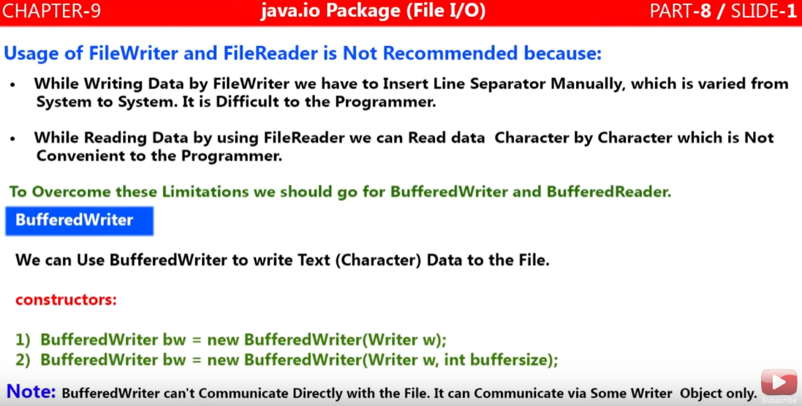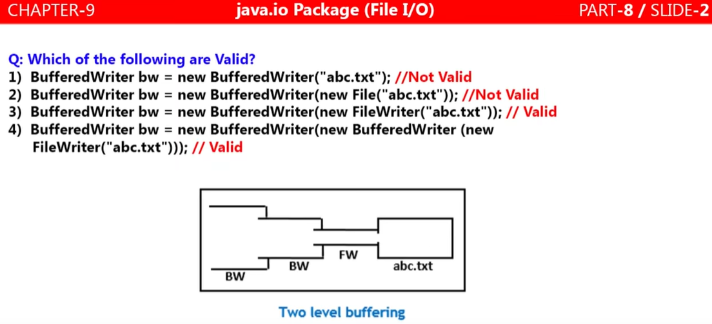

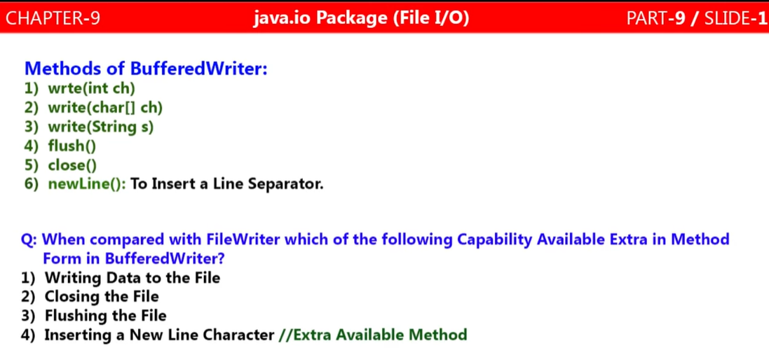

Note: As we can see that BW contains the same method what FW contains except one method newline() to insert a line separator.

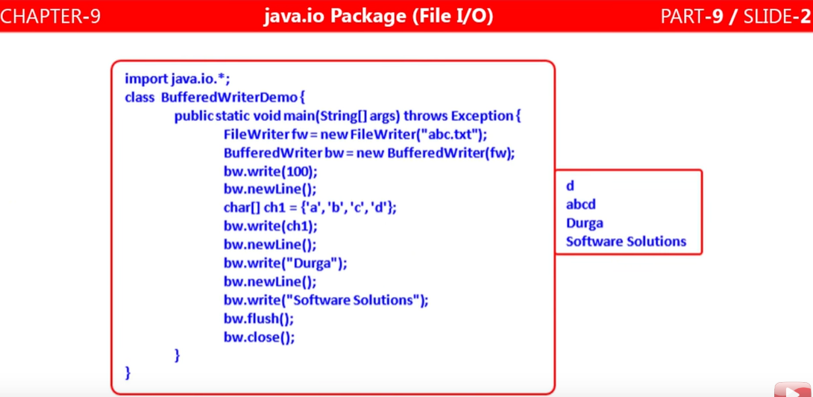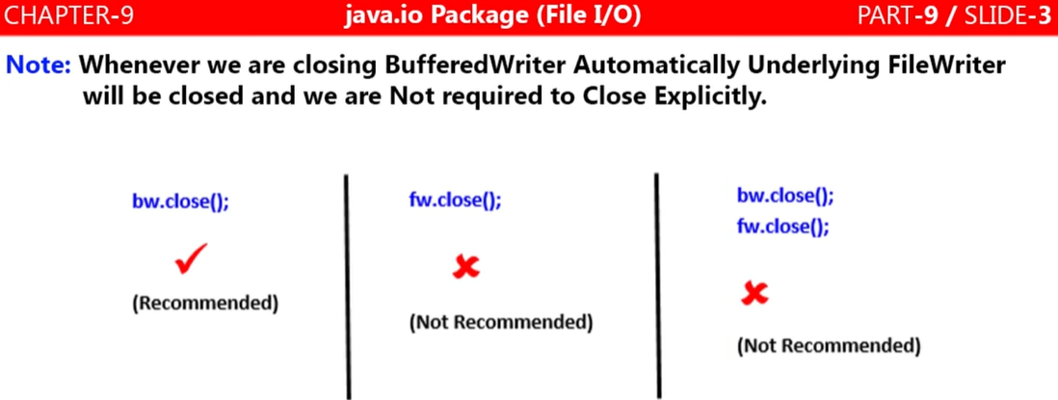

|  |  |
| --- | --- |
| **package**com.file.handling;  **import**java.io.BufferedWriter;  **import**java.io.File;  **import**java.io.FileWriter;  **import**java.io.IOException;  **publicclass**BufferedWriterDemo {  **publicstaticvoid**main(String[] args) **throws** IOException {    File file = **new** File("BufferedWriter.csv");  FileWriter fw = **new**FileWriter(file ,**true**);  BufferedWriter bw = **new** BufferedWriter(fw);  bw.write(100);  bw.write("urga");  bw.newLine();  **char**[] ch = {'a','b'};  bw.write(ch);  bw.flush();  bw.close();  }  } | **package**com.file.handling;  **import**java.io.BufferedWriter;  **import**java.io.File;  **import**java.io.FileWriter;  **import**java.io.IOException;  **publicclass**BufferedWriterDemo {  **publicstaticvoid**main(String[] args) **throws** IOException {    File file = **new** File("BufferedWriter.csv");  FileWriter fw = **new** FileWriter(file);  BufferedWriter bw = **new** BufferedWriter(fw);  bw.write(100);  bw.write("urga");  bw.newLine();  **char**[] ch = {'a','b'};  bw.write(ch);  bw.flush();  bw.close();  }  } |
| **In the above example in the FileWriter we have passed true which appends the content to file whenever we execute the program** | **In the above example in the FileWriter we have not passed true which means it will overwrite whenever we execute the above program** |
|  | **Here in every execution we get same result while in case of true the content is getting appended to the file as shown in the LHS screen shot.** |
| FileWriter fw = **new**FileWriter(file ,**true**);  BufferedWriter bw = **new** BufferedWriter(fw); | |
| The above two line can be written as:  **BufferedWriter bw = new BufferedWriter (new FileWriter(file));**  **Here BW communicate with FW and FW communicates with file directly.**  **If we want to increase some more buffer size then above code can be written as**  **BufferedWriter bw = new BufferedWriter (new BufferedWriter (new FileWriter(file)));**  **Here BW communicate with BW objects and BW communicates with FW Objects and Finally FW communicates with File objects directly** | |

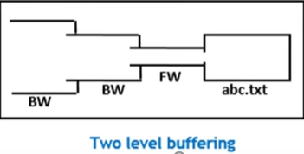

**BufferedReader Class:**

**As in case FileReader it reads character data(text data) character by character from the file. But if want to read the file line by line then BufferedReader class can be used.**

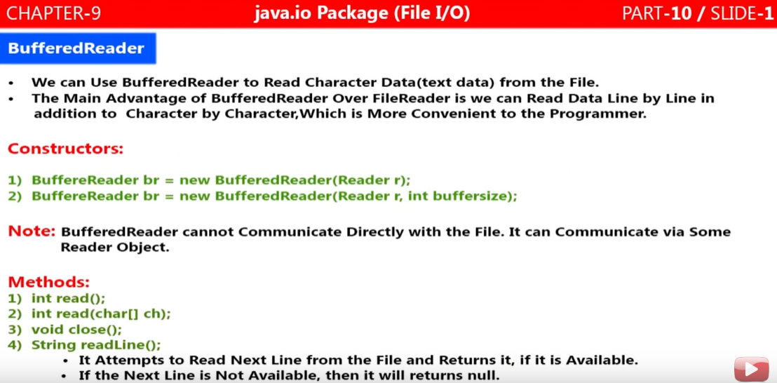

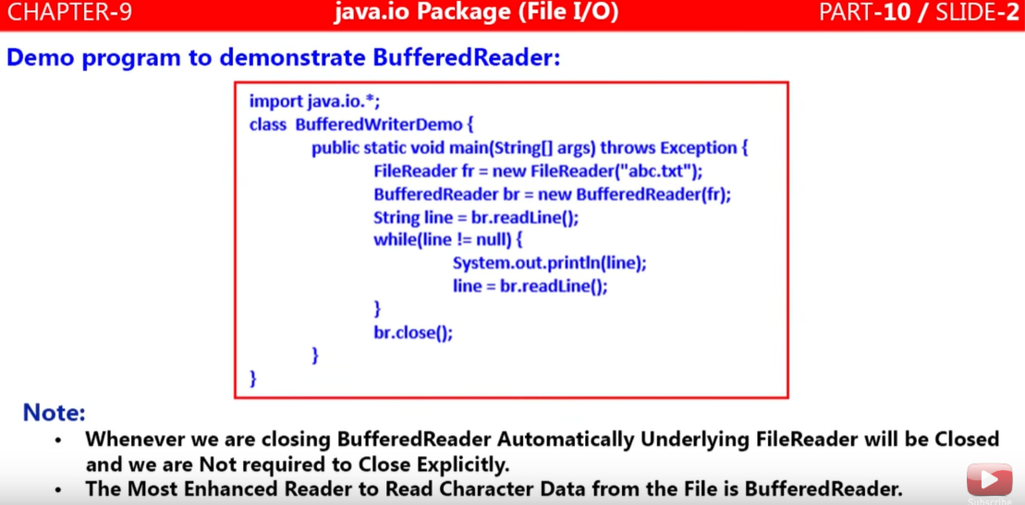

**Note : Like BufferedWriter the BufferedReader class also cannot communicate directly with file.it also need FileReader object which communicates with file directly**

**SYNTAX: BufferedReader in= new BufferedReader (new FileReader("foo.in"));**

|  |  |
| --- | --- |
| **package**com.file.handling;  **import**java.io.BufferedReader;  **import**java.io.File;  **import**java.io.FileReader;  **import**java.io.IOException;  **publicclass**BufferedReaderDemo {  **publicstaticvoid**main(String[] args) **throws** IOException {  File file = **new** File("BufferedWriter.csv");  FileReader fr = **new** FileReader(file);  BufferedReader br= **new** BufferedReader(fr);  String line = br.readLine();  **while**(line!=**null**) {  System.***out***.println(line);  line =br.readLine();  }  br.close();  }  } | **Output :**  durga  abc |
| File file = **new** File("BufferedWriter.csv");  FileReader fr = **new** FileReader(file);  BufferedReader br= **new** BufferedReader(fr);  **The above all three line can be written in one line as given below**  **BufferedReader br= newBufferedReader(new FileReader("BufferedWriter.csv"));**  BR communicates with FileReader and FR communicates with File directly  **BufferedReader br= newBufferedReader(new BufferedReader(new FileReader("BufferedWriter.csv")));** | |

**Note :**

**The only difference between FileReader and BufferedReader class is that BR contains one extra method String readLine() for reading file line by line. This readLine() method should keep on executing untill it returns null**

**PrintWriter Class:**

**As we already have two writter [FileWriter] and [BufferedWritter] then now why we need to have PrintWriter to write data in the file ?**

As we know that in FW and BW we need to write “\n” and readLine() method for new line which Is just burden for programmer and if we write fr.write(100) or bw.write(100) then it will write character [d] to the file i.e. it writes chacracter data or string data only.

Now if we want to write 100 or 10.5 or any boolean value like TRUE or FALSE then it is obivious that it could be written as string within double coute like asbw.write(“100”), bw.write(“10.5”), bw.write(“true”) to file, which decreases the performances.

To overcome these above issues PrintWriter class concept came. We can write any kind of primitive data to the file diecectly, which is not possible in case of FW and BW class concept.

Another advantage is that we don’t need to use readLine() or “\n” for line seperator PW provides method pw.println(100) which will print 100 and cursur automatically comes to second line.

As the BW can’t communicate directly with File and so to communicate with file we need to use FW which communicate with file directly. PrintWriter class can communicate with file directly or via FW class object also. In PW it is not mandatory to use any FileWriter object.

PW contains all the method whatever we have in FW and BW like [write(int c) , write(char[] ch) , write(String str), flush(), close(). Apart from these method PW contains some powerfull mehtod like print() and println() methods like given below. Detail we can see in the down in the method section.

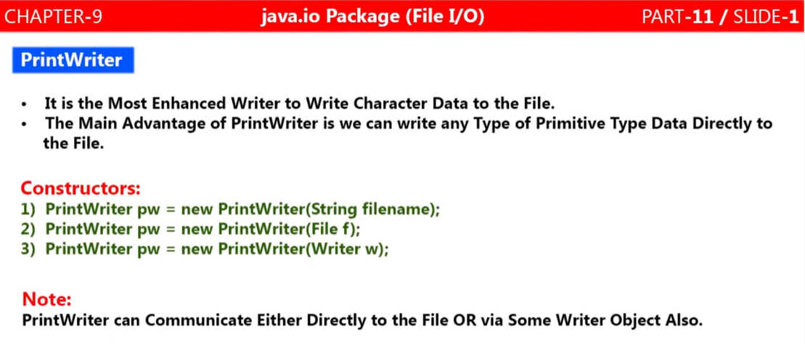

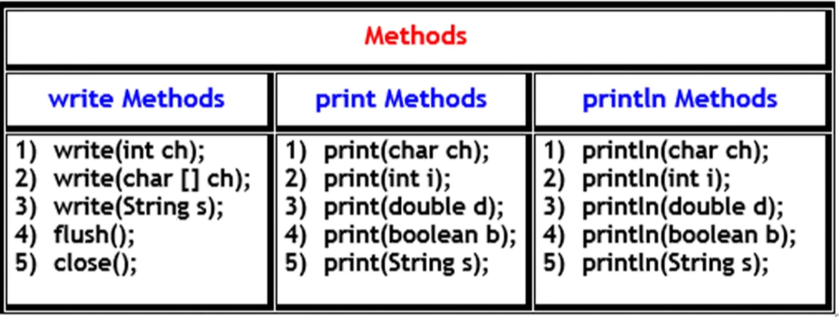

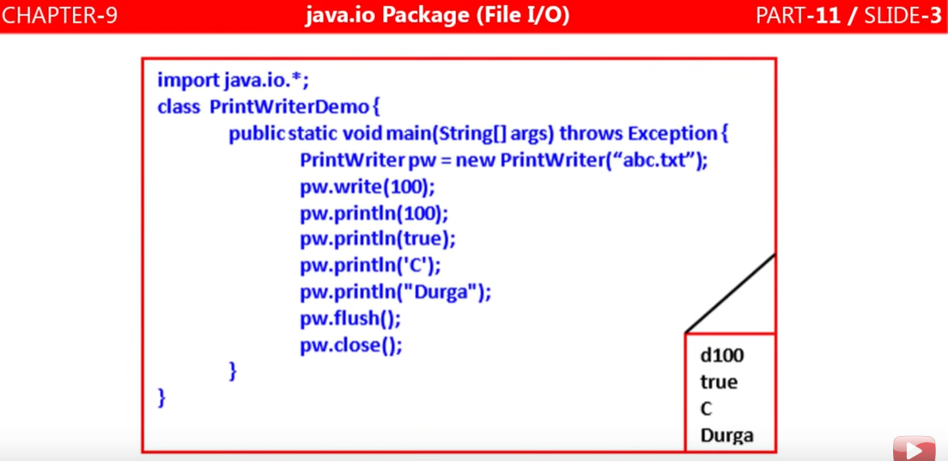

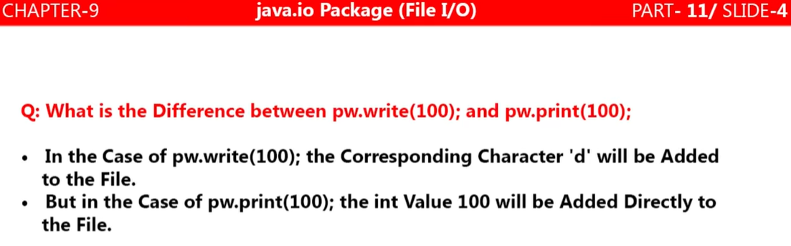

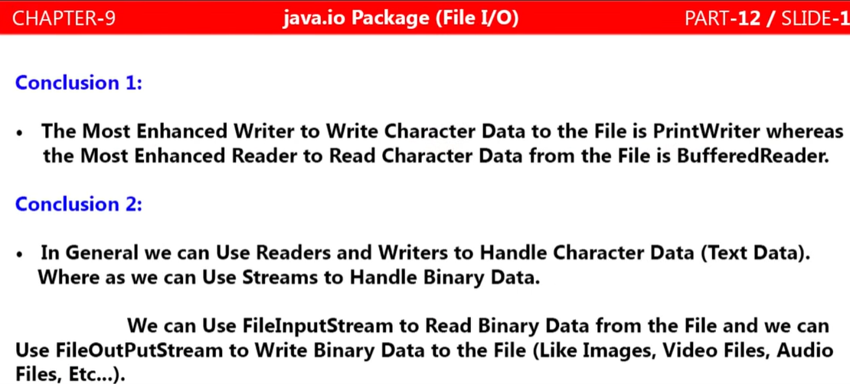

**FileInputStream and FileOutputStream:**

**As we know that data can be divided into two part.**

1. **Character data (text data)**
2. **Binary data( video files, audio files , images etc)**

**To handle character data (text) data we have Readers / Writerslike FileReader, BufferedReader / FileWriter, BufferedWriters, PrintWriter**

**Similarly To handle binary data we have inputStream to write and outputStream to read**

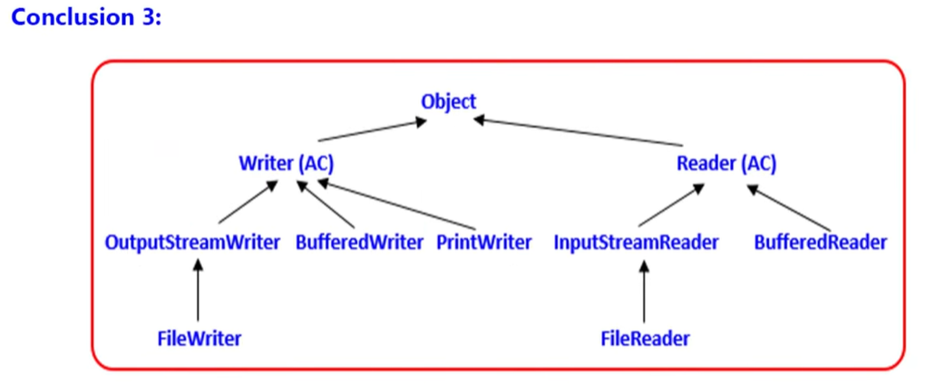

**Here Object is the Parent class which contains Writer(Abstract Class) and Reader(Abstract Class) as chile.**

**Writer(AC) conatins three child class, OutputStreamWriter, BufferedWriter, PrintWriter.And OutputStreamWriter inturn contain one child class FileWriter.**

**Reader(AC) contains two child class, InputStreamReader, BufferedReader. InputStreamReader in turn contain one child class FileReader.**

**Note: There is no any PrintReader class in I/O**

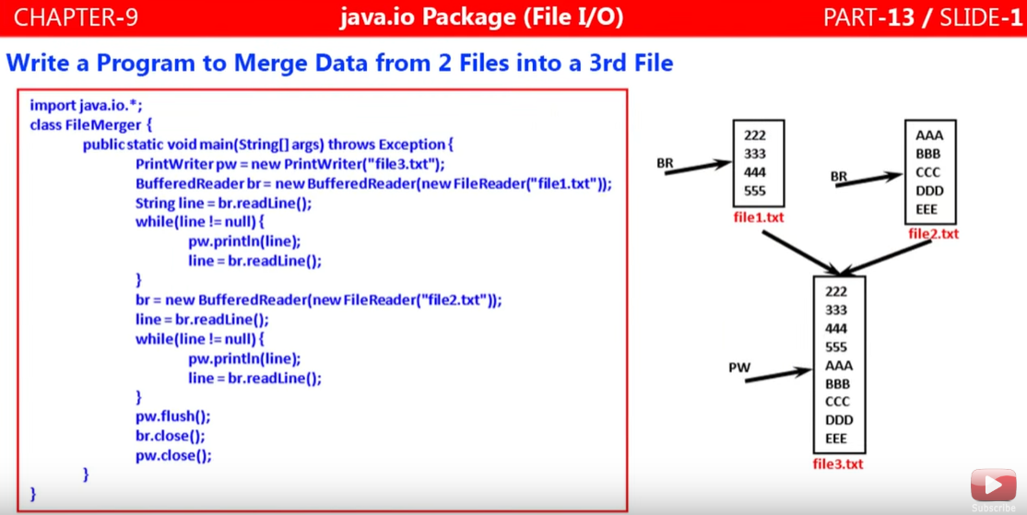

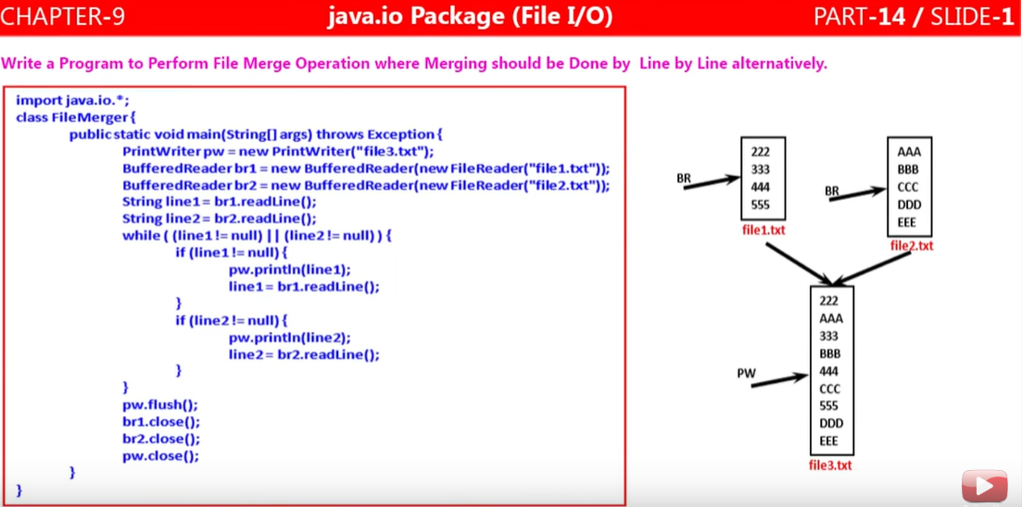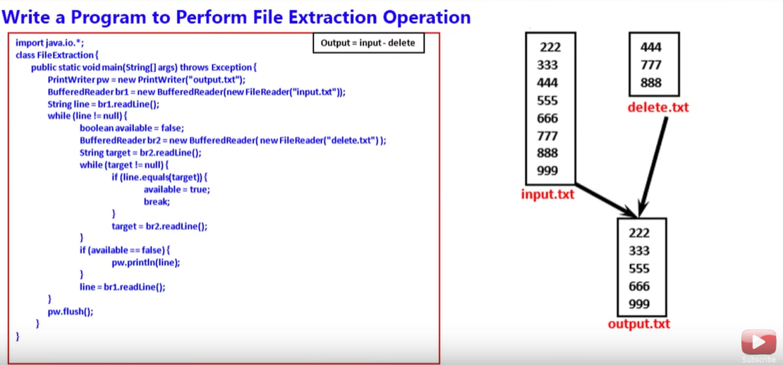

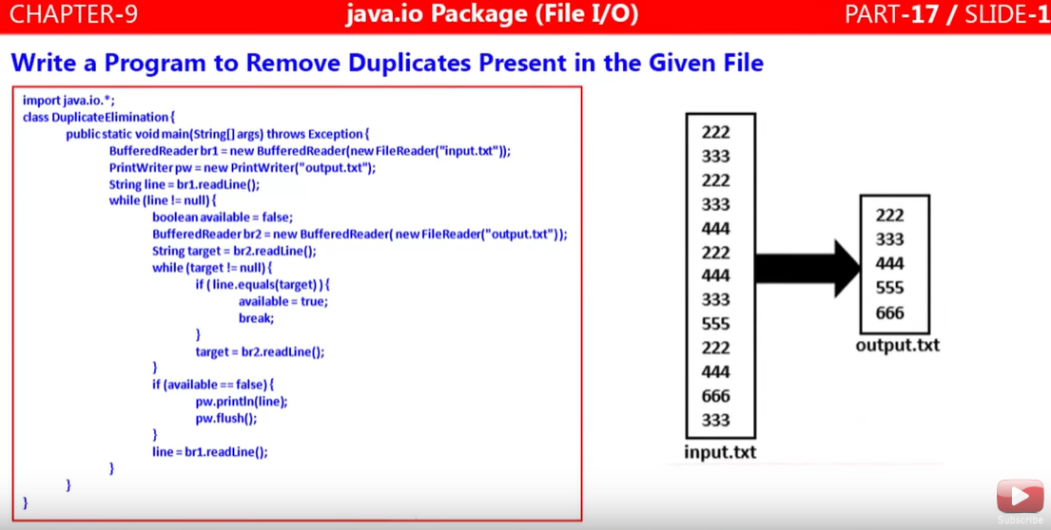

**FileInputStream and FileOutputStream:**

**FileOutputStream:**<https://www.journaldev.com/19438/java-fileoutputstream>

<https://www.journaldev.com/19187/java-fileinputstream>

1. **FileOutputStream is meant for writing streams of raw bytes such as image, audio, videos data (Binary data). For writing streams of characters, we should go for FileWriter or BufferedWriter or PrintWriter.**
2. **FileOutputStream is an output stream for writing data to a File or FileDescriptor.**
3. **FileOutputStream is used for writing streams of raw bytes such as image data. It’s good to use with bytes of data that can’t be represented as text such as PDF, excel documents, image files etc.**
4. **FileOutputStream class is a subclass of OutputStream class.**

**Constructor of FileOutputStream**

|  |
| --- |
| 1. **FileOutputStream fout=new FileOutputStream (File file)**   **Creates a file output stream to write to the file represented by specified file object.** |
| 1. **FileOutputStream fout1=newFileOutputStream (File file, boolean append);**   **Creates a file by the specified File object. If the second argument is true, then bytes will be appeended to the end of the file rather than the beginning** |
| 1. **FileOutputStream fout2= new FileOutputStream (FileDescriptorfdObj);** |
| 1. **FileOutputStream fout3= new FileOutputStream (String str);** |
| 1. **FileOutputStream fout3= new FileOutputStream (String str, boolean append);** |

1. **Important methods:**

* **void close() :**Closes this file output stream and releases any system resources associated with this stream.
* **protected void finalize() :**Cleans up the connection to the file, and ensures that the close method of this file output stream is called when there are no more references to this stream**.**
* **void write(byte[] b) :**Writes b.length bytes from the specified byte array to this file output stream.
* **void write(byte[] b, int off, int len) :**Writes len bytes from the specified byte array starting at offset off to this file output stream.
* **void write(int b) :**Writes the specified byte to this file output stream.

**Following steps are to be followed to create a text file that stores some characters (or text) from Console**

1. **Reading data:** First of all, data should be read from the keyboard. For this purpose, associate the keyboard to some input stream class. The code for using DataInputSream class for reading data from the keyboard is as:

**DataInputStream dis =new DataInputStream(System.in);**

Here System.in represent the keyboard which is linked with DataInputStream object

1. **Send data to OutputStream:** Now , associate a file where the data is to be stored to some output stream. For this , take the help of FileOutputStream which can send data to the file. Attaching the file.txt to FileOutputStream can be done as:

**FileOutputStream fout=new FileOutputStream(“file.txt”);**

1. **Reading data from DataInputStream:** The next step is to read data from DataInputStream and write it into FileOutputStream . It means read data from dis object and write it into fout object, as shown here:
2. **ch=(char)dis.read();**

**fout.write(ch);**

1. **Close the file:** Finally, any file should be closed after performing input or output operations on it, else the data of the may be corrupted. Closing the file is done by closing the associated streams. For example, fout.close(): will close the FileOutputStream ,hence there is no way to write data into the file.

|  |
| --- |
| **package**com.file.handling;  **import**java.io.BufferedOutputStream;  **import**java.io.DataInputStream;  **import**java.io.FileOutputStream;  **import**java.io.IOException;  **publicclass** FileOutputStreamsDemo2 {  **publicstaticvoid**main(String[] args) **throws** IOException{  //attach keyboard to DataInputStream  **DataInputStreamdis=newDataInputStream(System.*in*);**  // attach file to FileOutputStream  **FileOutputStream fout=new FileOutputStream("file.txt");**    //attach FileOutputStream to BufferedOutputStream  **BufferedOutputStreambout=newBufferedOutputStream(fout,1024);**  System.***out***.println("Enter text (! at the end):");  **char**ch;  //read characters from dis into ch. Then write them into bout.  //repeat this as long as the read character is not @  **while**((ch=(**char**)dis.read())!='!') {  **bout.write(ch);**  }  //close the file  bout.close();  }  } |

**When we run the above program it will ask to input from keyboard:**

Enter text (! at the end):

**Example to be practiced in Ecliplse:**